Oracle Database Administration Services

KE_Oracle Active DLL issue while Patching on Windows

Submitted to



By



CIS, Wipro Limited

Document Details

Project Name | Innogy SE
Account | CIS
IT Component/Application Title | KE_Oracle Active DLL issue while Patching on Windows
Current Version | 1.2
List of Contributors | Jiten Patel
Customer Contact Information

Version History
(All revisions made to this document must be listed in chronological order. All revisions must be approved. Review and Approval can be done by an internal source or by the customer)
Version | Date of Revision | Description | Author | Reviewed By | Approved By
1.0 | 22-05-2018 | Intial Draft | Jiten Pansara | Balaji Ankalle | Yogesh Desai
1.1 | 23-05-2018 | Document Completed | Jiten Pansara | Balaji Ankalle | Yogesh Desai
1.2 | 20-12-2018 | Updated the content | Abhishek Kansal | JitenKumar Pansara | Santosh Badiger

Short Description:
Oracle Active DLL issue while Patching on Windows server.
Problem Description:
Following files are active :
E:\Oracle\product\10.2.0\client_1\bin\oci.dll
ApplySession failed during prerequisite checks: Prerequisite check “CheckActiveFilesAndExecutables” failed.
System intact, OPatch will not attempt to restore the system
OPatch failed with error code = 74
Root cause:
An service will be active which needs to stopped before starting patching.
Workaround:
To resolve the issue, follow below steps:

You will get below screen when the DLL was active.
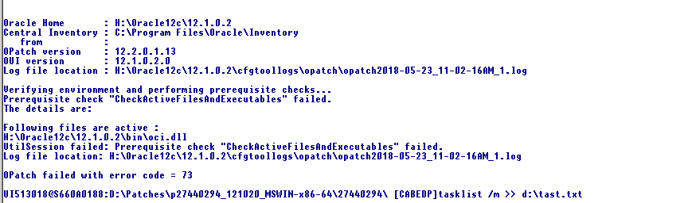

You need to use tasklist /m >> d:\DLL.txt as show in above screenshot.
Once you run the command, it will create a file named as DLL.txt, you can search for the DLL which are active as shown below.
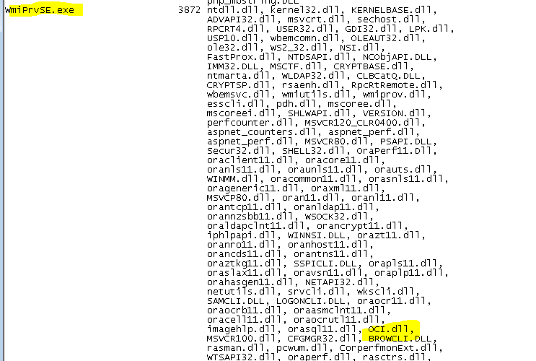
Now go to services and stop the services as per the screenshot, in our case we have stopped Windows managed Instrumentation service.

Try to apply the patch again.

